1. Frame Assembly

NO | Part NO. | Description | Number
NO | Part NO. | Description | Three-thread | Four-thread | Five-thread
1 | 795-0101 | Machine frame | 1 | 1 | 1
2 | KA04E-1 | Needle thread cover plate | 1 | 1 | 1
3 | 795-0103 | Left upper cover | 1 | 1 | 1
4 | 795-0104 | Left upper cover pad | 1 | 1 | 1
5 | KA09 | Needle plate | 1 | 1 | 1
6 | KA14 | Rear oil adhesive | 1 | 1 | 1
7 | KA22 | Oil seal | 1 | 1 | 1
8 | KA25-1 | Rear cover | 1 | 1 | 1
9 | KA25-2 | Rear cover oil seal | 1 | 1 | 1
10 | KA26 | Oil cover | 1 | 1 | 1
11 | 795-0111 | Cover | 1 | 1 | 1
12 | KA28 | Oil cover washer | 1 | 1 | 1
13 | KA29 | Cover washer | 1 | 1 | 1
14 | KA33 | Rivet | 2 | 2 | 2
15 | 795 01-18 | Machine model plate | 1 | 1 | 1
16 | KA38 | Plastic tube | 1 | 1 | 1
17 | KA39 | Pin | 2 | 2 | 2
18 | KA40 | Oil screen | 1 | 1 | 1
19 | KA42 | Snap ring | 1 | 1 | 1
20 | KA21 | Oil seal I | 1 | 1 | 1
21 | KA24 | Oil seal II | 1 | 1 | 1
22 | 240190 | Oil amount adjusting pin | 1 | 1 | 1
23 | 795-0123 | Oil back cuprum tube | 1 | 1 | 1
1 | SK292 | Front cover screw | 3 | 3 | 3
2 | SK290 | Needle plate screw | 2 | 2 | 2
3 | SK299 | Needle plate set screw | 1 | 1 | 1
4 | SK216 | Needle thread cover plate top silk | 1 | 1 | 1
5 | SK357 | Needle thread cover plate set screw | 1 | 1 | 1
6 | SK268 | Main cover bearing regulate screw | 1 | 1 | 1
7 | NK26 | Main cover bearing regulate nut | 1 | 1 | 1
8 | SK257 | Rear cover screw | 11 | 11 | 11
9 | SK261 | cover screw | 1 | 1 | 1
10 | SK280 | cover screw II | 1 | 1 | 1
11 | SK401 | Oil pan join screw | 4 | 4 | 4
12 | WK23 | Washer | 4 | 4 | 4
13 | SW02 | Elasticity washer | 4 | 4 | 4
14 | SK400 | Hexagon socket screw | 4 | 4 | 4
15 | SK272 | Screw | 1 | 1 | 1
16 | SK308 | Screw | 1 | 1 | 1
About Serial Number: О -denote part; □ -denote bolt, washer & nut.
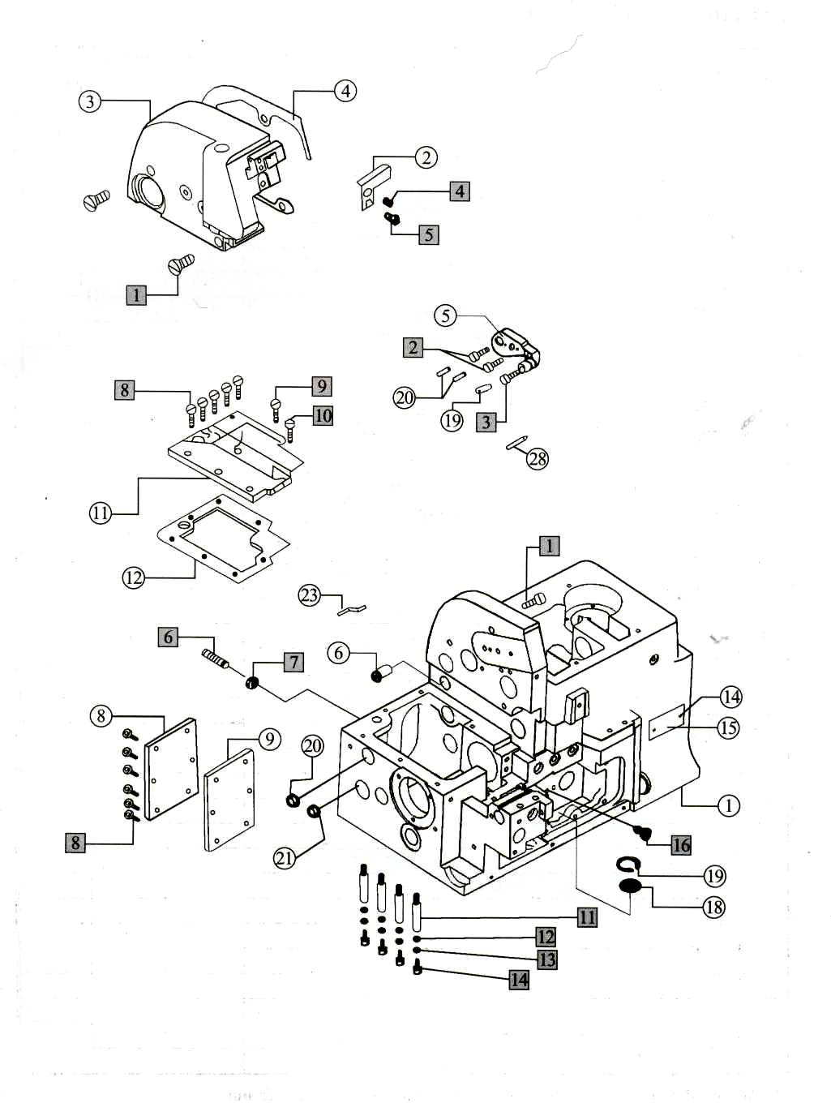

2. Cloth Plate Assemblies

NO | Part NO. | Description | Number
NO | Part NO. | Description | Three-thread | Four-thread | Five-thread
1 | KB01E | Cloth plate | 1 | 1 | 0
 | KB02E | Cloth plate | 0 | 0 | 1
2 | KB03 | Washer | 1 | 1 | 1
3 | KB05 | Rubber bushing | 4 | 4 | 4
4 | KB05E | Rubber bushing | 1 | 1 | 1
5 | KB06E-1 | Cloth plate shockproof screw | 1 | 1 | 1
6 | KB08 | Spring | 1 | 1 | 1
7 | KB12B | Cloth plate spring | 1 | 1 | 1
8 | KB15B | Cloth plate slider cover | 1 | 1 | 1
9 | KB17 | Cloth plate cover spring | 1 | 1 | 1
10 | KB22F | Cloth plate lower plate | 1 | 1 | 0
 | KB23F | Cloth plate lower plate | 0 | 0 | 1
11 | KB29 | Washer | 1 | 1 | 1
12 | KB31D-1 | Upper looper sealing plate | 1 | 1 | 1
13 | KB31D-2 | Upper looper sealing plate washer | 1 | 1 | 1
1 | SK262 | Upper looper sealing plate screw | 3 | 3 | 3
2 | SK279 | Set screw | 1 | 1 | 1
3 | SK217 | Screw | 2 | 2 | 2
4 | NK26 | Set nut big cover stable screw | 2 | 2 | 2
5 | SK403 | Screw | 1 | 1 | 1
6 | WK09 | Screw washer | 1 | 1 | 1
7 | NK23 | Screw nut | 1 | 1 | 1
8 | WK06 | Washer | 2 | 2 | 2
9 | SK221 | Big cover spring screw | 2 | 2 | 2
10 | SK560 | Big cover joint screw | 3 | 3 | 3
11 | WK05 | Big cover joint screw washer | 3 | 3 | 3
About Serial Number: О - denote part; □ - denote bolt, washer & nut.
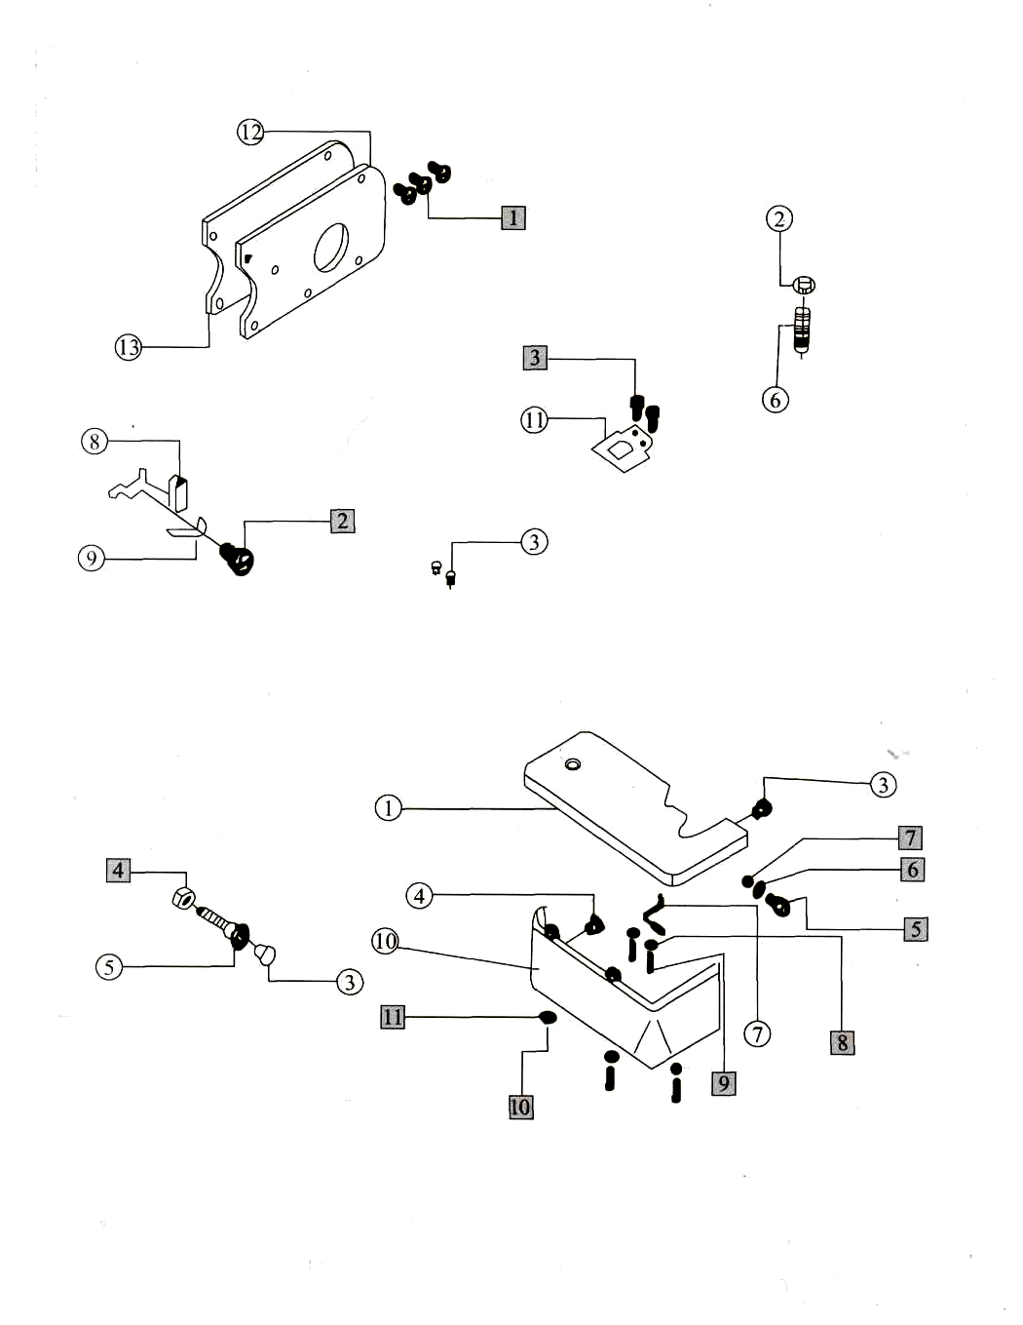

3. Cover Assemblies

NO | Part NO. | Description | Number
NO | Part NO. | Description | Three-thread | Four-thread | Five-thread
1 | 795-0301 | Upper cover | 1 | 1 | 1
2 | 795-0302 | Upper cover washer | 1 | 1 | 1
3 | 795-0303 | Thread guide supporter | 1 | 1 | 1
4 | 209550-PB | Belt cover | 1 | 1 | 1
5 | KC13 | Thread cover spring | 1 | 1 | 1
6 | KC15 | Cloth guide plate | 1 | 1 | 1
7 | KC17 | Oil guide II | 1 | 1 | 1
8 | KC18 | Pin | 1 | 1 | 1
9 | KC20 | Front spring | 1 | 1 | 1
10 | KC21E | Front cover | 1 | 1 | 1
11 | KC22B | Front cover guard | 1 | 1 | 0
 | KC23B | Front cover guard | 0 | 0 | 1
12 | KC24B | Front cover hinge | 1 | 1 | 1
13 | KC25B | Hinge pin | 1 | 1 | 1
14 | KC28 | Front cover hinge spring | 1 | 1 | 1
15 | KC29 | Front cover hinge washer | 1 | 1 | 1
16 | 795-0316 | Trade mark plate | 1 | 1 | 1
17 | KC39-4 | Oil flow sindow | 1 | 1 | 1
18 | KC36 | Front cover snap guard | 1 | 1 | 1
19 | KC55B | Oil guard I | 1 | 1 | 1
20 | 795-0320 | Oil level gauge washer | 1 | 1 | 1
21 | KC62 | Pin | 1 | 1 | 1
22 | 795-0322 | Oil level gauge plate | 1 | 1 | 1
23 | KC69F | Oil sight | 1 | 1 | 1
24 | KC61F | Upper cover | 1 | 1 | 1
25 | 209551 | Right frame plate | 1 | 1 | 1
1 | SK257 | Upper cover long screw | 2 | 2 | 2
2 | SK278 | Upper cover short screw | 2 | 2 | 2
3 | 004009 | Thread guard screw | 2 | 2 | 2
4 | SK233 | Upper cover spring screw | 7 | 7 | 7
5 | MA84 | Washer | 2 | 2 | 2
6 | SK262 | Cloth guide plate screw | 2 | 2 | 2
7 | SK238 | Oil guard screw I | 2 | 2 | 2
8 | SK235 | Screw | 3 | 3 | 3
9 | SK250 | Screw | 2 | 2 | 2
10 | SK576 | Front cover hinge screw | 3 | 3 | 3
11 | EK03 | Snap spring | 1 | 1 | 1
12 | 007176 | Belt cover screw | 3 | 3 | 3
13 | 007019 | Right frame plate screw | 2 | 2 | 2
About Serial Number: О -denote part; □ -denote bolt, washer & nut.
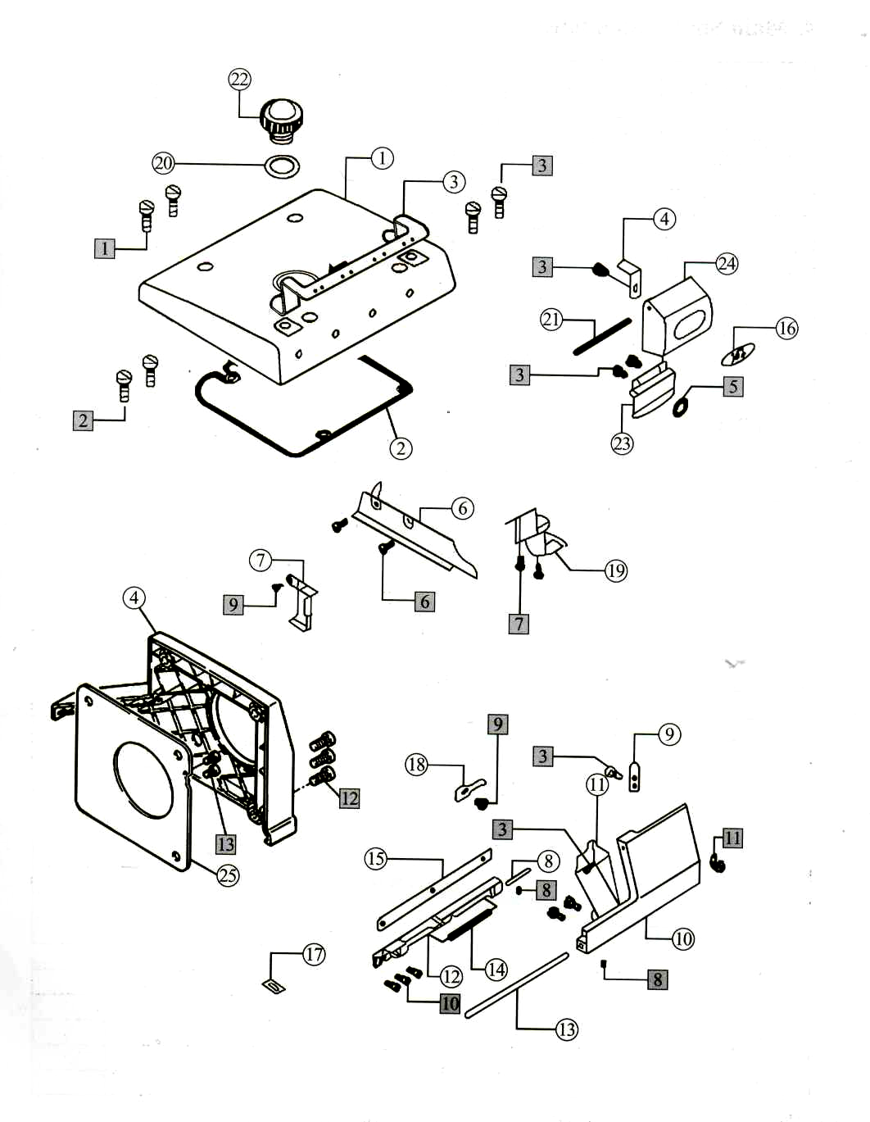

4. Main Shaft Assemblies

NO | Part NO. | Description | Number
NO | Part NO. | Description | Three-thread | Four-thread | Five-thread
1 | KD01 | Main shaft | 1 | 1 | 1
2 | KD09 | wheel | 1 | 1 | 1
3 | KD10D | Rear shaft bearing cover | 1 | 1 | 1
4 | KD12D | Rear shaft bearing washer | 1 | 1 | 1
5 | KD13 | Main shaft spring washer | 1 | 1 | 1
6 | KD14 | Main shaft bysgubg asm | 1 | 1 | 1
7 | KD15 | Seal ring | 1 | 1 | 1
8 | KD16 | Main shaft queen shaft bearing | 1 | 1 | 1
9 | KD17 | Oil pump worm | 1 | 1 | 1
10 | KD19 | Main shaft bearing | 1 | 1 | 1
11 | KD20 | Shaft and bushing washer | 1 | 1 | 1
12 | KD21 | Main shaft left bushing | 1 | 1 | 1
13 | KD22 | Bearing 80200 | 1 | 1 | 1
14 | KD27D | Bearing cover | 1 | 1 | 0
 | KD26D | Bearing cover | 0 | 0 | 1
15 | KD28D | Bearing cover washer | 1 | 1 | 1
16 | KD35D | Pulley | 1 | 1 | 1
17 | KD33 | Bulgy pulley shaft | 0 | 0 | 1
1 | SK374 | Pulley screw | 1 | 1 | 1
2 | SW02 | Pulley screw washer | 1 | 1 | 1
3 | SK347 | Pulley set screw | 2 | 2 | 2
4 | SK414 | Pulley set screw | 1 | 1 | 1
5 | SK257 | Bearing cover screw | 3 | 3 | 3
6 | SK270 | Oil pump worn screw | 1 | 1 | 1
7 | SK396 | Screw | 2 | 2 | 2
8 | SK235 | Screw | 1 | 1 | 1
9 | SK241 | Bearing cover screw | 3 | 3 | 3
About Serial Number: О - denote part; □ - denote bolt, washer & nut.
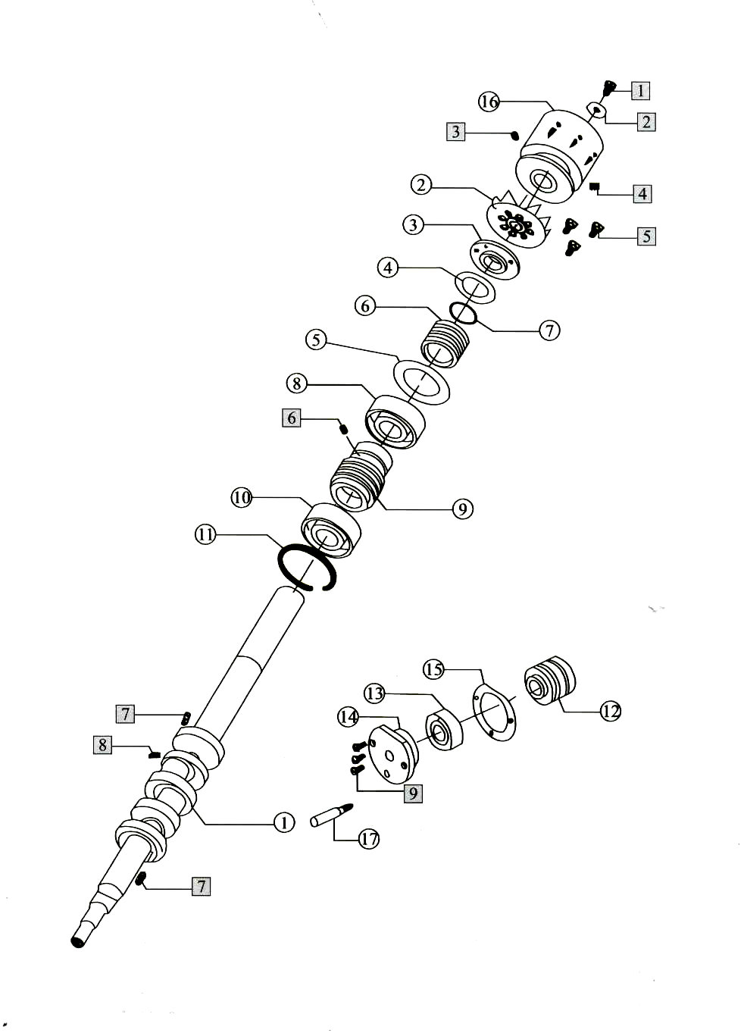

5. Needle Bar Assemblies

NO | Part NO. | Description | Number
NO | Part NO. | Description | Three-thread | Four-thread | Five-thread
1 | KFO1F | Needle bar driving frame rock shaft | 1 | 1 | 1
2 | KF02 | Eccentric shaft | 1 | 1 | 1
3 | KF05 | Needle bar shaft bushing back | 1 | 1 | 1
4 | KF07 | Snap ring | 1 | 1 | 1
5 | KF09 | Throat driving crank | 1 | 1 | 1
6 | KF10F-E | Oil wick | 1 | 1 | 1
7 | KF11 | Needle bearing | 1 | 1 | 1
8 | KF12 | Washer ring | 1 | 1 | 1
9 | KF14 | Throat clip guide ping | 1 | 1 | 1
10 | KF16 | Oil wick | 1 | 1 | 1
11 | KF17 | Throat bar rock crank | 1 | 1 | 1
12 | 795-0512 | Needle driving shaft bearing | 1 | 1 | 1
13 | KF19 | Seal ring | 2 | 2 | 2
14 | 795-0514 | Needle driving shaft bearing | 1 | 1 | 1
15 | KF21 | Snap ring | 2 | 2 | 2
16 | KF23 | Balance block | 1 | 1 | 1
17 | KF26 | Needle bar frame rock shaft crank | 0 | 1 | 0
 | KF25 | Needle bar frame rock shaft crank | 1 | 0 | 1
18 | KF28 | Needle bar connecting rod | 1 | 1 | 1
19 | KF30 | Connecting link pin | 1 | 1 | 1
20 | KF31 | Washer ring | 1 | 1 | 1
21 | KF32 | Throat clip guide bushing | 1 | 1 | 1
22 | KF33 | Needle bar | 1 | 1 | 1
23 | KF34 | Oil felt | 1 | 1 | 1
24 | KF35 | Oil wick | 1 | 1 | 1
25 | KF35F-1 | Plastic tube | 1 | 1 | 1
26 | KF37 | Oil wick | 2 | 2 | 2
27 | KG142-E | Needle clamp | 0 | 1 | 0
 | KG131-E | Needle clamp | 1 | 0 | 0
 | KG153-E | Needle clamp | 0 | 0 | 1
 | KG155-E | Needle clamp (for thick) | 0 | 0 | 1
28 | DC*27 | Needle | 1 | 2 | 2
29 | KF38 | Oil seal | 1 | 1 | 1
1 | SK293 | Snap ring screw | 2 | 2 | 2
2 | SK612 | Hexagon socket screw | 1 | 1 | 1
3 | SK291 | Balance block position screw | 2 | 2 | 2
4 | SK270 | Frame rock shaft set screw | 3 | 3 | 3
5 | SK385 | Shaft position screw | 2 | 2 | 2
6 | SK287 | Screw | 1 | 1 | 1
7 | SK204 | Screw | 1 | 1 | 1
8 | SK212 | Screw | 1 | 1 | 1
9 | SK221 | Screw | 1 | 1 | 1
10 | SK216 | Screw | 3 | 3 | 3
11 | EK01 | Snap ring | 1 | 1 | 1
12 | 005292-HV | Screw | 2 | 2 | 2
About Serial Number: О -denote part; □ -denote bolt, washer & nut.
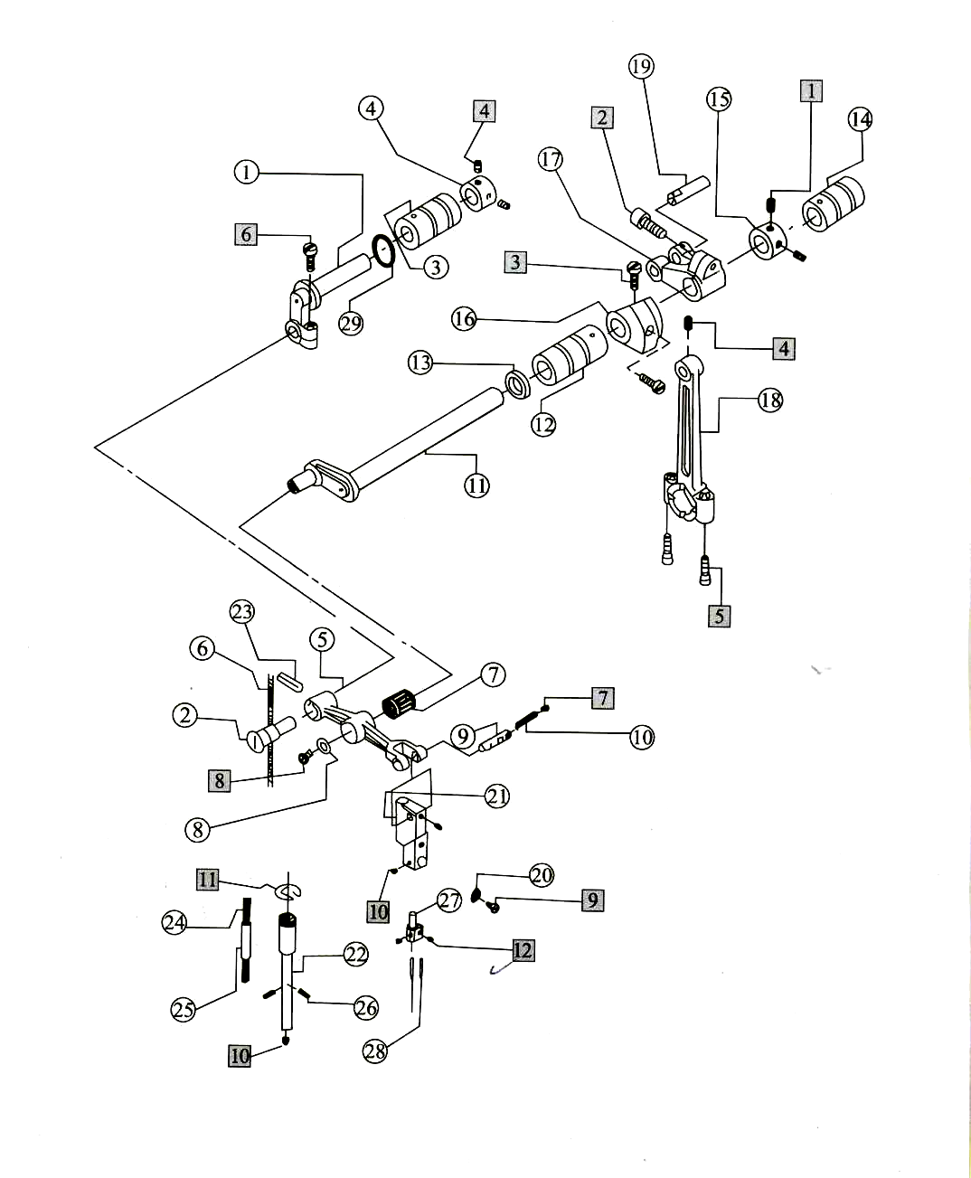

6. Thread Guide Assemblies

NO | Part NO. | Description | Number
NO | Part NO. | Description | Three-thread | Four-thread | Five-thread
1 | 208447-UA | Thread tension screw | 3 | 4 | 4
2 | 208448 | Thread tension spring | 3 | 4 | 4
3 | 201037 | Thread tension spring | 1 | 2 | 2
4 | 201068 | Thread tension spring | 1 | 1 | 1
5 | 201086 | Thread tension spring | 1 | 1 | 1
6 | 208450-UA | Thread tension spring | 3 | 4 | 4
7 | 210319 | Thread tension disc | 6 | 8 | 8
8 | 208449 | Thread tension disc washer | 3 | 4 | 4
9 | 005082A | Thread tension screw | 3 | 4 | 4
10 | 209622 | Thread guide | 0 | 1 | 1
11 | 202849 | Thread guide | 3 | 3 | 3
12 | KG11F | Upper thread take-up | 1 | 1 | 0
 | KG60F | Upper thread take-up | 0 | 0 | 1
13 | KG 12 | Oil box | 1 | 1 | 1
14 | KG13 | Oil felt | 1 | 1 | 1
15 | KG14 | Thread guide | 1 | 1 | 1
16 | KG15D | Oil box washer | 1 | 1 | 1
17 | KG16 | Oil felt | 1 | 1 | 1
18 | KG 17 | Tension spring | 1 | 1 | 1
19 | KG18 | Thread controller disc holder | 1 | 1 | 1
20 | KG19 | Spring | 1 | 1 | 1
21 | KG21 | Thread controller disc guide bushing | 1 | 1 | 1
22 | KG24-1 | Throat plate positioning rod | 2 | 2 | 2
23 | KG24-2D | Throat plate bracket | 1 | 1 | 1
24 | KG54 | Thread mark guide | 1 | 1 | 0
 | KG42 | Thread mark guide | 0 | 0 | 1
25 | KG59 | Teat needle guard | 1 | 1 | 1
26 | KG471 | Front needle guard | 1 | 0 | 0
 | KG472 | Front needle guard | 0 | 1 | 0
 | KG35 | Front needle guard | 0 | 0 | 1
27 | E800 | Throat plate | 1 | 0 | 0
 | E919 | Throat plate | 0 | 1 | 0
 | E982 | Throat plate | 0 | 0 | 1
28 | KG25 | Thread guide | 0 | 0 | 1
29 | KG31D | Needle guard I | 0 | 0 | 1
30 | KG37 | Needle guard II | 0 | 0 | 1
31 | KU18 | Needle guard bracket | 1 | 1 | 0
 | KG39 | Needle guard bracket | 0 | 0 | 1
32 | KG26-E | Snap plate | 1 | 1 | 1
33 | KG46 | Snap plate washer | 1 | 1 | 1
1 | SK216 | Screw | 1 | 1 | 1
2 | SK260 | Throat screw | 2 | 2 | 2
3 | SK230 | Front needle snap screw | 1 | 1 | 1
4 | SK299 | Throat plate bracket screw | 2 | 2 | 2
5 | SK250 | Thread guide holder screw | 2 | 2 | 2
6 | SK207 | Oil box set screw | 1 | 1 | 1
7 | SK359 | Oil box set screw | 1 | 1 | 1
8 | SK209 | Rear needle guard screw | 2 | 2 | 2
9 | SK243 | Needle guard screw | 1 | 1 | 1
10 | WK05 | Needle guard washer | 1 | 1 | 1
11 | SK233 | „ Thread take up screw | 2 | 2 | 2
12 | SK242 | Snap plate screw I | 2 | 2 | 2
13 | SK235 | Snap plate screw II | 1 | 1 | 1
14 | SK236 | Snap plate set screw | 1 | 1 | 1
15 | SK275 | screw | 2 | 2 | 2
About Serial Number: О -denote part; □ -denote bolt, washer & nut.
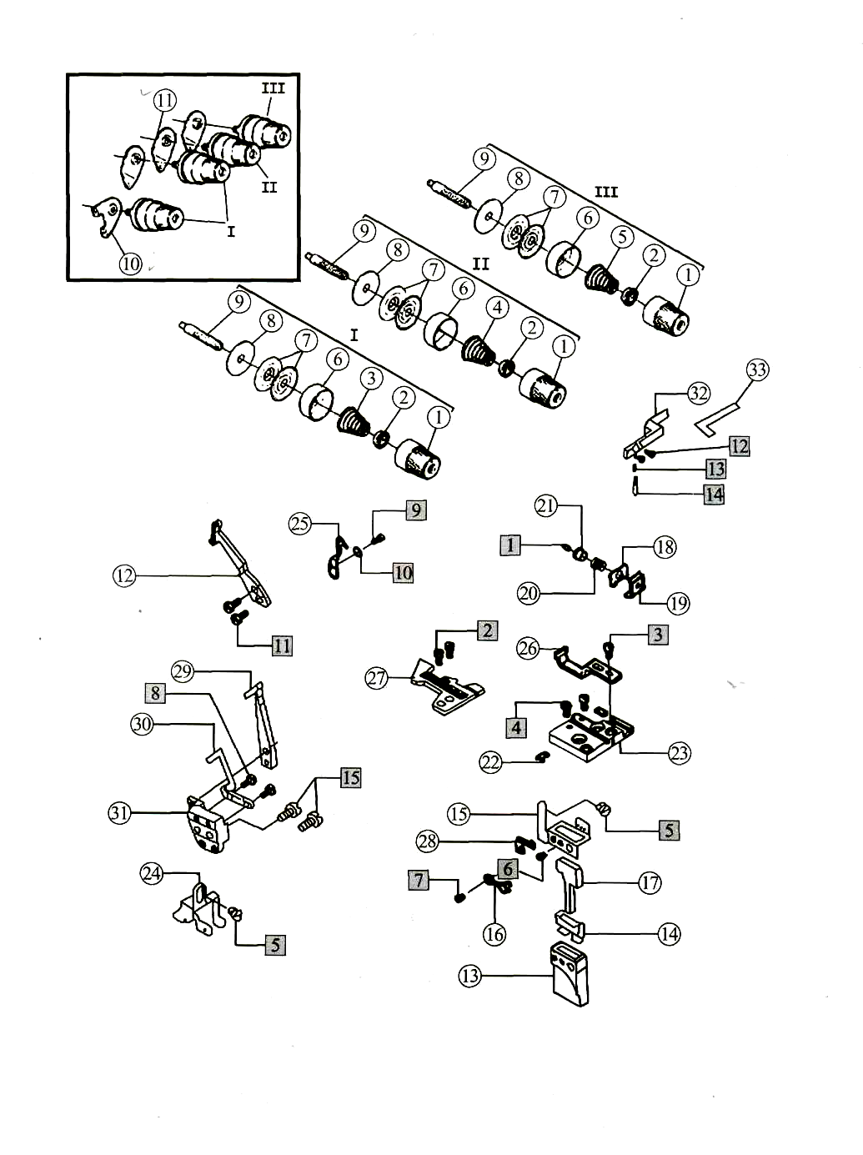

7. Upper Looper Assemblies

NO | Part NO. | Description | Number
NO | Part NO. | Description | Three-thread | Four-thread | Five-thread
1 | KJ01B | Looper link | 2 | 2 | 2
2 | KJ06B | Looper link holder | 2 | 2 | 2
3 | KJ13F | Thickness washer | 0 | 1 | 0
 | KJ10F | Thickness washer | 1 | 0 | 1
4 | KJ15 | Upper looper shaft | 1 | 1 | 1
5 | KJ16 | Big washer | 1 | 1 | 1
6 | KJ19F | Upper looper shaft rear bushing | 1 | 1 | 1
7 | KJ20 | Upper looper shaft front bushing | 1 | 1 | 1
8 | KJ21 | Upper looper shaft oil seal | 1 | 1 | 1
9 | KJ22 | Upper looper shaft crank | 1 | 1 | 1
10 | KJ26 | Upper looper shaft bar | 1 | 1 | 1
11 | KJ27 | Connecting rod shaft pin | 1 | 1 | 1
12 | KJ28 | Washer | 1 | 1 | 1
13 | KJ29 | Oil wick | 1 | 1 | 1
14 | KJ30F | Upper looper slide block | 1 | 1 | 1
15 | KJ33 | Oil felt | 2 | 2 | 2.
16 | KJ34 | Oil felt | 1 | 1 | 1
17 | KJ37 | Oil wick | 2 | 2 | 2
18 | KJ39F | Screen oil plate | 1 | 1 | 1
19 | KJ40F | Felt plate | 1 | 1 | 1
20 | KJ41 | Thread holder snap plate | 1 | 1 | 1
21 | KJ42E | Upper looper shaft slide bar bracket | 1 | 1 | 1
22 | KJ44 | Oil seal | 2 | 2 | 2
23 | KJ47 | Oil tube | 1 | 1 | 1
24 | KJ49 | Oil tube | 1 | 1 | 1
25 | KJ61D | Thread amount regulating plate | 1 | 1 | 1
26 | KJ63 | Upper looper thread guard | 1 | 1 | 1
27 | KJ66D | Upper looper shaft thread plate | 1 | 1 | 1
28 | KJ71 | Shaft bearing guard | 2 | 2 | 2
29 | KJ79 | Lower looper holder copper | 1 | 1 | 1
30 | LP26 | Looper | 1 | 1 | 1
31 | KJ11B-E | Upper looper crank bearing | 0 | 1 | 0
 | KG09B-E | Upper looper crank bearing | 1 | 0 | 1
32 | KJ58 | Thread tube | 2 | 2 | 2
33 | KJ68 | Tow for thread guide | 1 | 1 | 1
1 | SK385 | Shaft screw | 8 | 8 | 8
2 | SK408 | Screw | 2 | 2 | 2
3 | SK280 | Upper looper crank screw | 1 | 1 | 1
4 | WK11 | Washer | 1 | 1 | 1
5 | SK216 | Link pin set screw | 1 | 1 | 1
6 | SK612 | Nexagon socket screw | 1 | 1 | 1
7 | SK261 | Upper looper shaft screw | 1 | 1 | 1
8 | SW03 | Washer | 1 | 1 | 1
9 | SK257 | Thread guide screw | 2 | 2 | 2
10 | SK250 | Screw | 2 | 2 | 2
11 | SK262 | Screw | 1 | 1 | 1
12 | SK223 | Thread guide screw | 2 | 2 | 2
13 | WK06 | Thread guide washer | 2 | 2 | 2
14 | SK454 | Screw | 1 | 1 | 1
15 | SK300 | Screw | 1 | 1 | 1
16 | SK221 | Screw | 1 | 1 | 1
17 | SK451 | Screw | 1 | 1 | 1
18 | SK229 | Upper looper set screw | 1 | 1 | 1
About Serial Number: О - denote part; □ - denote bolt, washer & nut.
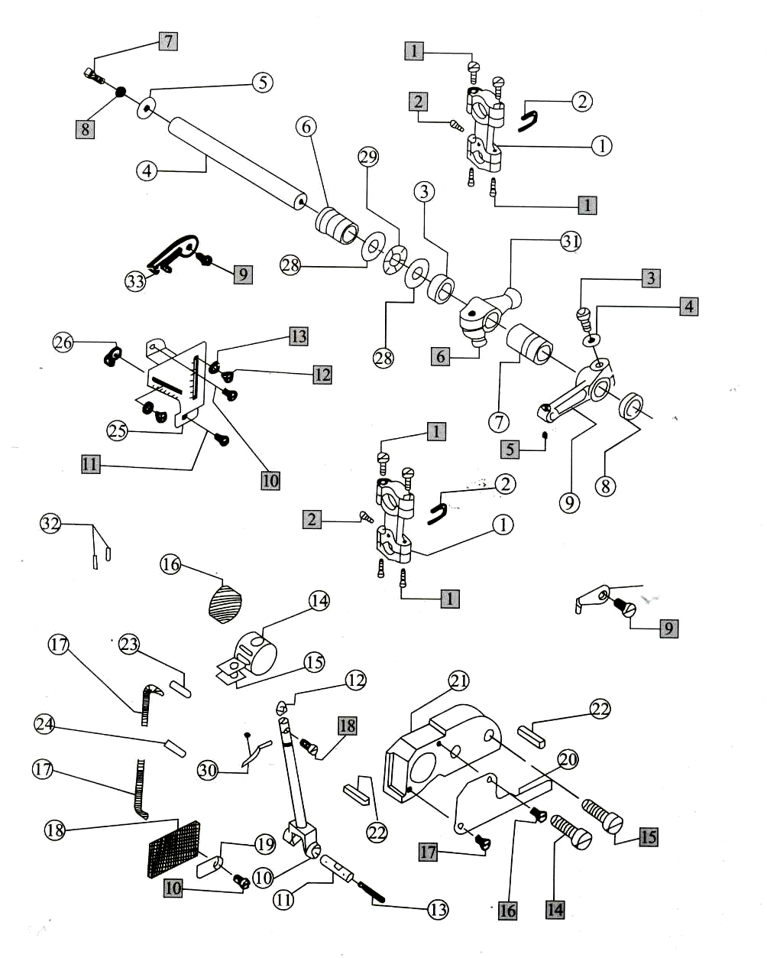

8. Lower Looper Assemblies

NO | Part NO. | Description | Number
NO | Part NO. | Description | Three-thread |  | Four-thread |  |  | Five-thread
1 | KL15 | Lower looper shaft copper bushing | 1 |  | 1 |  |  | 0
 | KL11 | Washer | 0 |  | 0 |  |  | 1
2 | KL17 | Lower looper shaft washer | 1 |  | 1 |  |  | 1
3 | KL20 | Oil seal | 1 |  | 1 |  |  | 2
4 | KL21 | Lower looper front bushing | 1 |  | 1 |  |  | 1
5 | KL22D | Lower looper rear bushing | 1 |  | 1 |  |  | 1
6 | KL23-3 | Lower looper holder | 1 |  | 1 |  |  | 1
7 | KL23-4 | Lower looper crank washer | 2 |  | 2 |  |  | 5
8 | KL25 | Lower looper | 1 |  | 1 |  |  | 0
9 | KL32-A | Copper washer | 1 |  | 1 |  |  | 1
10 | KL38 | Thread guide | 1 |  | 1 |  |  | 1
11 | KL43 | Lower looper thread guide | 1 |  | 1 |  |  | 1
12 | KL46 | Lower кюрегЗ -thread guide | 1 |  | 1 |  |  | 1
13 | KL57 | Lower looper shaft | 1 |  | 1 |  |  | 0
 | KL16 | Lower looper shaft | 0 |  | 0 |  |  | 1
14 | KL612 | Lower looper crank | 1 |  | 1 |  |  | 0
 | KL09B | Lower looper crank | 0 |  | 0 |  |  | 1
1 | SK261 | Low looper shaft screw | 1 |  | 1 |  |  | 1
2 | SW03 | Washer | 1 |  | 1 |  |  | 1
3 | SK612 | Crank screw | 1 |  | 1 |  |  | 1
4 | SK298 | Lower looper holder screw | 1 |  | 1 |  |  | 1
5 | WK11 | Lower looper holder washer | 1 |  | 1 |  |  | 1
6 | WK05 | Lower looper holder washer | 1 |  | 1 |  |  | 1
7 | SK241 | Lower looper | 1 |  | 1 |  |  | 1
8 | SK257 | Thread guide screw | 1 |  | 1 |  |  | 1
9 | SK311 | Crank screw | 0 |  | 0 |  |  | 2
10 | SK229 | Crank screw | 0 |  | 0 |  |  | 2
About Serial Number: О - denote part; □ -denote bolt, washer & nut.
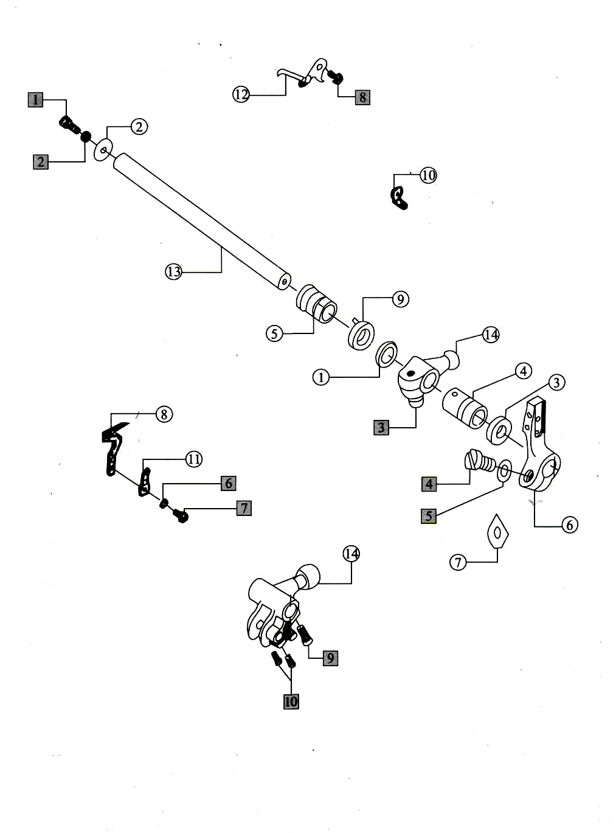

9. Front Looper Assemblies

NO | Part NO. | Description | Number
NO | Part NO. | Description | Three-thread | Four-thread | Five-thread
1 | KM01 | Front looper shaft holder | 0 | 0 | 1
2 | KM04 | Front looper | 0 | 0 | 1
3 | KM06 | Front looper shaft regulating washer | 0 | 0 | 1
4 | KM08 | Front looper crank | 0 | 0 | 1
5 | KM11 | Regulating plate | 0 | 0 | 1
6 | KM12 | Regulating plate pin | 0 | 0 | 2
7 | KM15 | Oil thread | 0 | 0 | 2
8 | KM17 | Front looper shaft front bushing | 0 | 0 | 1
9 | KM18 | Front looper shaft rear bushing | 0 | 0 | 1
10 | KM26 | Front looper shaft | 0 | 0 | 1
11 | KM27D | Driving lever | 0 | 0 | 1
12 | KM28 | Driving crank | 0 | 0 | 1
13 | KM29D | Front looper slide block | 0 | 0 | 1
1 | SK209 | Thread guide screw | 0 | 0 | 1
2 | SK230 | Front looper guide set screw | 0 | 0 | 1
3 | SK298 | Front looper holder set screw | 0 | 0 | 1
4 | WK11 | Washer | 0 | 0 | 2
5 | SK251 | Front looper crank screw | 0 | 0 | 2
6 | SK612 | Crank holder set screw | 0 | 0 | 1
7 | SK270 | Nexagon socket set screw | 0 | 0 | 1
8 | SK499 | Driving lever set screw | 0 | 0 | 1
9 | SK441 | Driving lever set screw | 0 | 0 | 1
10 | EK03 | Snap ring | 0 | 0 | 1
About Serial Number: О - denote part; □ - denote bolt, washer & nut.
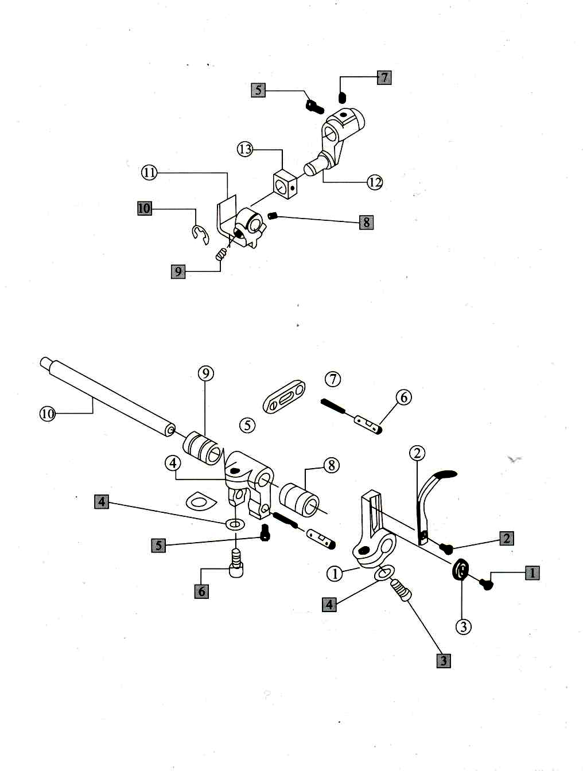

10. Cam Assemblies

NO | Part NO. | Description | Number
NO | Part NO. | Description | Three-thread | Four-thread | Five-thread
1 | KN01 | Horizontal shaft link | 0 | 0 | 1
2 | KN02 | Needle bearing | 0 | 0 | 1
3 | KN03 | Snap ring | 0 | 0 | 1
4 | KN05 | Pin | 0 | 0 | 1
5 | KN08 | Horizontal shaft crank | 0 | 0 | 1
6 | KN10 | Horizontal shaft | 0 | 0 | 1
7 | KN11 | Left horizontal shaft bushing | 0 | 0 | 1
8 | KN12 | Right horizontal shaft bushing | 0 | 0 | 1
9 | KN13 | Oil seal | 0 | 0 | 1
10 | KN18 | Looper thread take-up cam | 0 | 0 | 1
11 | KN20 | Thread guide | 0 | 0 | 1
12 | KN22 | Thread | 0 | 0 | 2
13 | KN24 | Bracket | 0 | 0 | 1
14 | KN26 | Flat spring | 0 | 0 | 1
15 | KN27 | Astrict position plate | 0 | 0 | 1
16 | KN29 | Thread guide ring | 0 | 0 | 1
17 | KN32 | Thread guide | 0 | 0 | 1
18 | KN34 | Thread guide | 0 | 0 | 1
19 | KN36-1 | Thread pipe cover | 0 | 0 | 2
20 | KN36-2 | Thread pipe | 0 | 0 | 1
21 | KN37 | Bracket | 0 | 0 | 2
22 | KN38 | Bracket | 0 | 0 | 1
23 | KN40 | Screw | 0 | 0 | 1
24 | KN42 | Tension disc | 0 | 0 | 2
25 | KN43 | Spring | 0 | 0 | 1
26 | KN44 | Nut | 0 | 0 | 1
1 | SK205 | Bearing snap ring screw | 0 | 0 | 2
2 | SK216 | Cam set screw | 0 | 0 | 2
3 | SK612 | Crank set screw | 0 | 0 | 1
4 | WK11 | Crank washer | 0 | 0 | 1
5 | WK04 | Washer | 0 | 0 | 1
6 | NK25 | Nut | 0 | 0 | 1
7 | NK26 | Nut | 0 | 0 | 1
8 | SK257 | Screw | 0 | 0 | 1
9 | SK207 | Thread guide plate screw | 0 | 0 | 2
10 | SK233 | Thread guide plate screw | 0 | 0 | 2
11 | SK264 | Screw | 0 | 0 | 1
12 | SK250 | Thread guide screw | 0 | 0 | 3
13 | WK09 | washer | 0 | 0 | 1
About Serial Number: О - denote part; □ - denote bolt, washer & nut.
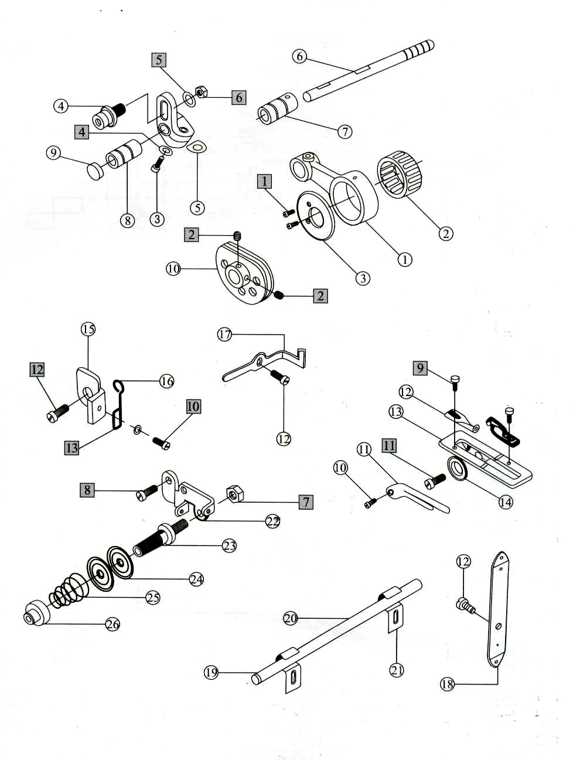

11. Differential Feed Assemblies

NO | Part NO. | Description | Number
NO | Part NO. | Description | Three-thread | Four-thread | Five-thread
1 | KP01 | Stitch length regulating shaft | 1 | 1 | 1
2 | KP02 | Spring | 1 | 1 | 1
3 | KP03 | Oil washer | 1 | 1 | 1
4 | KP05D | Stitch length regulation cam asm | 1 | 1 | 1
5 | KP06D | Stitch length regulating block | 1 | 1 | 1
6 | KP08 | Stitch length regulating block spring | 2 | 2 | 2
7 | KP09D | Stitch length cam | 1 | 1 | 1
8 | KP11 | Stitch length regulating plate | 1 | 1 | 1
9 | KP13D | Feed length cam | 1 | 1 | 1
10 | KP15 | Feed cam spring | 1 | 1 | 1
11 | KP18-1 | Feed cam pin | 1 | 1 | 1
12 | KP21 | Feed link | 1 | 1 | 1
13 | KP22 | Feed rod rolling pin bearing | 1 | 1 | 1
14 | KP23 | Feed crank | 1 | 1 | 1
15 | KP25 | Differential link | 1 | 1 | 1
16 | KP28 | Differential crank | 1 | 1 | 1
17 | KP30B | Pin | 1 | 1 | 1
18 | KP31 | Differential shaft bearing | 1 | 1 | 1
19 | KP32 | Oil seal | 1 | 1 | 1
20 | KP34 | Snap ring | 1 | 1 | 1
21 | KP35D | Spring | 1 | 1 | 1
22 | KP39 | Washer | 1 | 1 | 1
23 | KP43 | Regulating block | 1 | 1 | 1
24 | KP46 | Washer | 2 | 2 | 2
25 | KP59 | Feed bam | 1 | 1 | 0
26 | KP60 | Washer | 1 | 1 | 1
27 | KP62 | Differential regulation holder | 1 | 1 | 1
28 | KP63 | Regulating screw | 1 | 1 | 1
29 | KP64 | Regulating screw spring | 1 | 1 | 1
30 | KP65B | Differential regulating link | 1 | 1 | 1
31 | KP18-2 | Crank link cam | 0 | 0 | 1
1 | SK452 | Differential link screw | 1 | 1 | 1
2 | SK612 | Differential crank screw | 2 | 2 | 2
3 | SK251 | Snap ring screw | 1 | 1 | 1
4 | WK24 | Washer | 1 | 1 | 1
5 | WK01 | Washer | 2 | 2 | 2
6 | SK262 | Differential position screw | 1 | 1 | 1
7 | SK221 | Spring screw | 1 | 1 | 1
8 | SK399 | Screw | 1 | 1 | 1
9 | SK250 | Differential regulating screw | 1 | 1 | 1
10 | SK257 | Differential regulating screw | 2 | 2 | 2
11 | SK270 | Screw | 4 | 4 | 4
12 | SK215 | Screw | 1 | 1 | 1
13 | SK219 | Feed cam screw | 1 | 1 | 1
14 | SK266 | Screw | 1 | 1 | 1
15 | SK261 | Stitch length screw | 1 | 1 | 1
About Serial Number: О - denote part; □ - denote bolt, washer & nut.
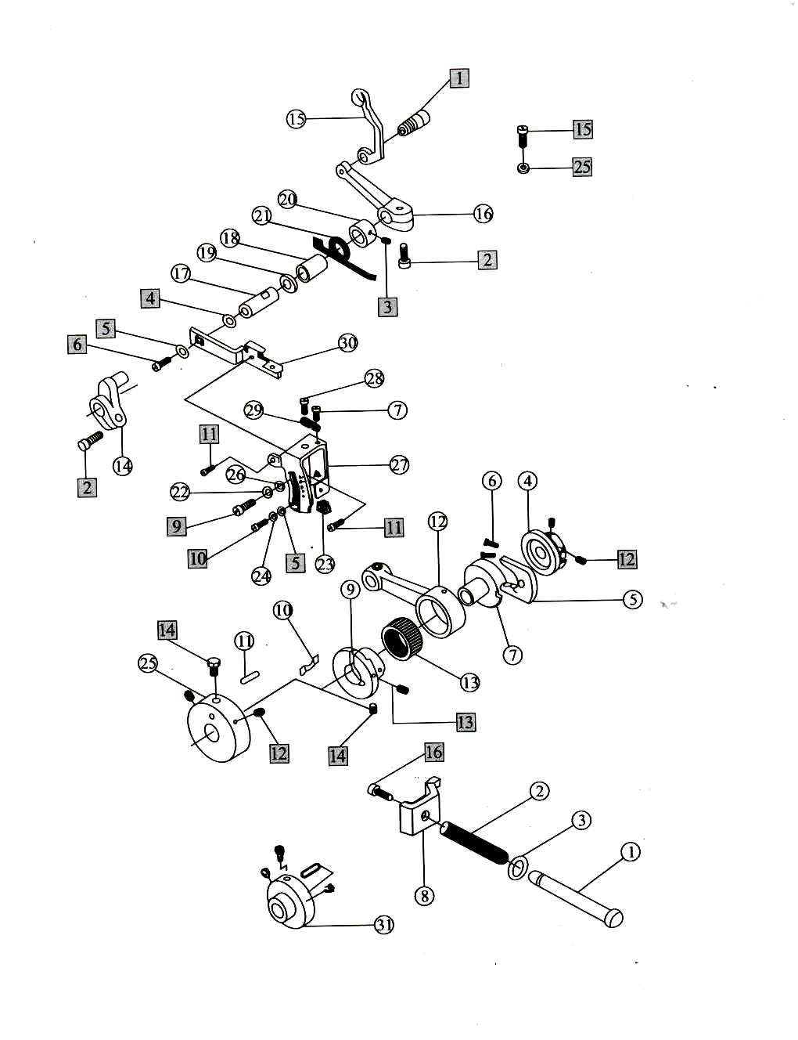

12. Feed Dog Assemblies

NO | Part NO. | Description | Number
NO | Part NO. | Description | Three-thread | Four-thread | Five-thread
1 | KQ05 | Dog link plate | 1 | 1 | 1
2 | KQ07 | Feed dog holder | 1 | 1 | 1
3 | KQ10 | Differential feed dog holder | 1 | 1 | 1
4 | 795-1204 | Feed dog lift slide block | 1 | 1 | 1
5 | KQ14 | Differential feed slide block | 1 | 1 | 1
6 | KQ15 | Slide block eccentric shaft | 1 | 1 | 1
7 | KQ17 | Slide block eccentric washer | 1 | 1 | 1
8 | KQ19 | Slide block eccentric shaft bushing | 1 | 1 | 1
9 | KQ21 | Feed shaft | 1 | 1 | 1
10 | KQ24 | Left feed shaft bushing | 1 | 1 | 1
11 | KQ25 | Right feed shaft bushing | 1 | 1 | 1
12 | KQ28 | Feed regulating crank | 1 | 1 | 1
13 | KQ31 | Washer | 1 | 1 | 1
14 | KQ33 | Feed dog holder link | 1 | 1 | 1
15 | KQ34 | Feed dog holder link bushing | 1 | 1 | 1
16 | KQ35 | Differential feed dog holder link bushing | 1 | 1 | 1
17 | KQ37-1 | Crank slide block cover | 1 | 1 | 1
18 | KQ37-2 | Crank slide block | 1 | 1 | 1
19 | KQ37-3 | Feed regulating crank | 1 | 1 | 1
20 | KQ40 | Differential feed dog holder link | 1 | 1 | 1
21 | KQ41 | Differential feed dog holder link bushing | 1 | 1 | 1
22 | KQ42 | holder link bushing washer | 2 | 2 | 2
23 | KQ46D | Screw oil plate | 1 | 1 | 1
24 | KQ47 | Feed dog carrier connection rod | 1 | 1 | 1
25 | KQ48 | Sealing connecting ring | 1 | 1 | 1
26 | KQ49 | Adjustable oil seal | 2 | 2 | 2
27 | KQ50 | Sealing connecting rod | 1 | 1 | 1
28 | KQ90 | Feed dog link eccentric shaft | 1 | 1 | 0
 | KQ30 | Feed dog link eccentric shaft | 0 | 0 | 1
29 | H445 | Differential dog | 1 | 1 | 0
 | H957 | Differential dog | 0 | 0 | 1
30 | D095 | Assistant feed dog | 1 | 1 | 0
 | D502 | Assistant feed dog | 0 | 0 | 1
31 | D440 | Main feed dog | 1 | 1 | 0
 | D008 | Main feed dog | 0 | 0 | 1
1 | SK251 | Screw | 1 | 1 | 1
2 | SK209 | Screw | 1 | 1 | 1
3 | SK241 | Screw | 1 | 1 | 1
4 | SK576 | Main feed dog screw | 2 | 2 | 2
5 | SK253 | Link screw | 2 | 2 | 2
6 | SK212 | Screw | 1 | 1 | 1
7 | SK612 | Crank screw | 2 | 2 | 2
8 | SK221 | Crank screw | 4 | 4 | 4
9 | SK343 | Crank slide block screw | 2 | 2 | 2
10 | SK259 | Tooth rocks screw II | 1 | 1 | 1
11 | SK277 | Tooth rocks screw I | 3 | 3 | 3
12 | SK256 | Screw | 1 | 1 | 1
13 | Nk25 | Nut | 1 | 1 | 1
About Serial Number: О - denote part; □ - denote bolt, washer & nut.
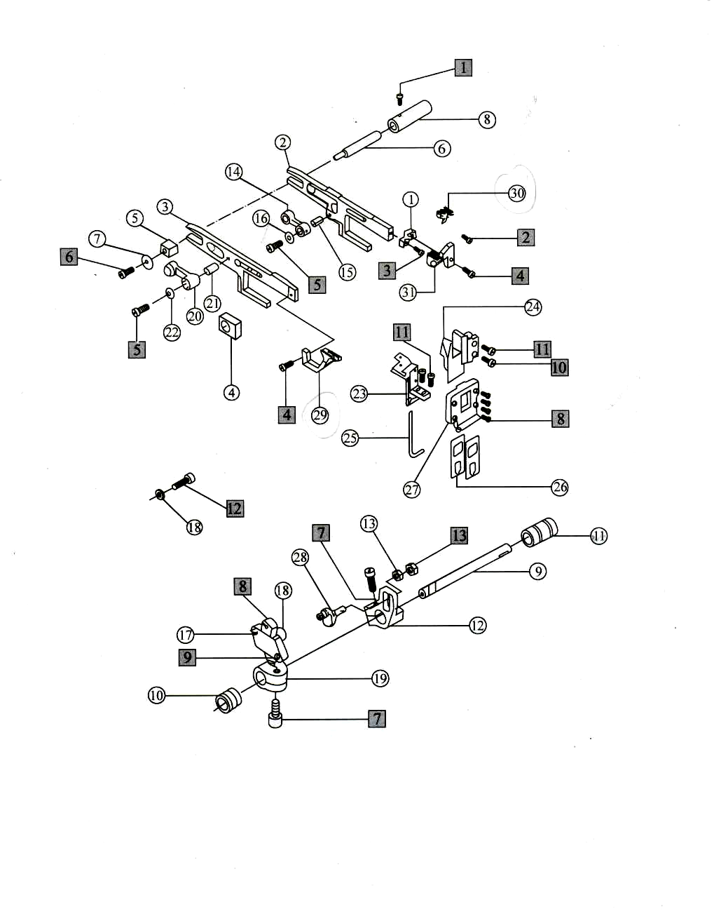

13. Trimming Assemblies

NO | Part NO. | Description | Number
NO | Part NO. | Description | Three-thread | Four-thread | Five-thread
1 | KR01 | Upper knife driving connecting link | 1 | 1 | 1
2 | KR04 | Upper knife crank | 1 | 1 | 0
 | KR03 | Upper knife crank | 0 | 0 | 1
3 | KR07 | Crank pin | 1 | 1 | 1
4 | KR09 | Upper knife frame rock shaft | 1 | 1 | 1
5 | KR12 | Left shaft bushing | 1 | 1 | 1
6 | 795-1306 | Right shaft bushing | 1 | 1 | 1
7 | KR14 | Washer | 1 | 1 | 1
8 | KR20 | Upper knife holder | 1 | 1 | 0
 | KR19 | Upper knife holder | 0 | 0 | 1
9 | KF21 | Snap ring | 1 | 1 | 1
10 | KR22 | Upper knife holder pin | 1 | 1 | 1
11 | KR23 | Upper knife | 1 | 1 | 1
12 | KR25 | Washer | 1 | 1 | 1
13 | KR27 | Lower knife holder | 1 | 1 | 0
 | KR26 | Lower knife holder | 0 | 0 | 1
14 | KR29 | Lower knife holder bushing | 1 | 1 | 1
15 | KR32 | Lower knife holder spring | 1 | 1 | 1
16 | KR33 | Lower knife holder | 1 | 1 | 1
17 | KR35 | Lower knife | 1 | 1 | 1
18 | KR36 | Lower knife holder lock plate | 1 | 1 | 1
1 | SK293 | Snap ring screw | 2 | 2 | 2
2 | SK612 | Upper knife crank set screw | 1 | 1 | 1
3 | SK270 | Upper knife crank pin screw | 1 | 1 | 1
4 | SK385 | Connecting link screw | 2 | 2 | 2
5 | SK277 | Upper knife holder screw | 1 | 1 | 1
6 | SK246 | Upper knife screw | 1 | 1 | 1
7 | SK261 | Screw | 1 | 1 | 1
8 | SK258 | Lower knife holder screw | 1 | 1 | 1
9 | SK275 | Lower knife snap plate screw | 1 | 1 | 1
10 | SK241 | Lower knife snap plate screw | 1 | 1 | 1
11 | NK23 | Lower knife snap plate screw | 1 | 1 | 1

About Serial Number: О - denote part; □ - denote bolt, washer & nut.
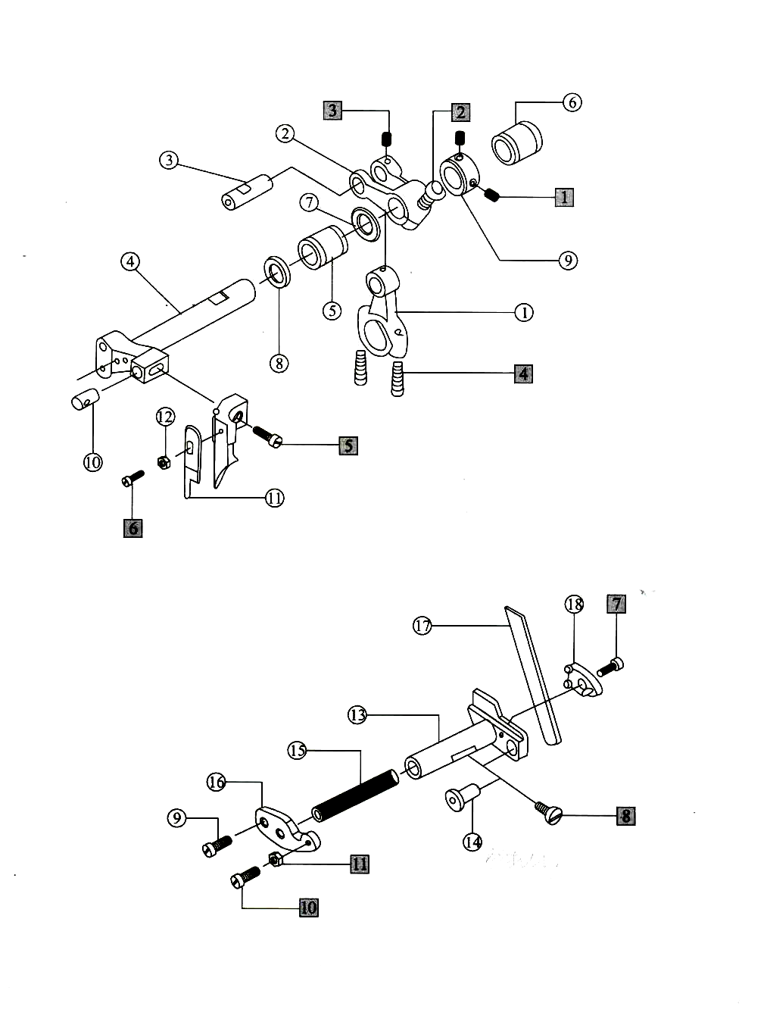

14. Presser Foot Assemblies

NO | Part NO. | Description | Number
NO | Part NO. | Description | Three-thread | Four-thread | Five-thread
1 | KS01 | Presser foot holder | 1 | 1 | 1
2 | KS02D | Presser foot shaft bushing | 1 | 1 | 1
3 | KS03 | Presser foot holder pin | 1 | 1 | 1
4 | KS09 | Presser foot holder shaft | 1 | 1 | 1
5 | KS10D | Presser foot shaft bushing | 1 | 1 | 1
6 | KS12 | Presser foot shaft snap ring | 1 | 1 | 1
7 | 795-1407 | Presser foot lifting spring | 1 | 1 | 1
8 | KS14F | Presser foot crank | 1 | 1 | 1
9 | KS18 | Presser foot lifting lever | 1 | 1 | 1
10 | KS20 | Hook | 1 | 1 | 1
11 | KS21 | Spring | 1 | 1 | 1
12 | KS24 | Thread cutting knife | 1 | 1 | 1
13 | 209603 | Presser bar | 1 | 1 | 1
14 | KS27 | Presser bar spring | 1 | 1 | 1
15 | KS28 | Presser bar screw | 1 | 1 | 1
16 | 205584 | Begin pin | 1 | 1 | 1
17 | 274013 | Presser bar shockproof block | 1 | 1 | 1
18 | 274016A | Presser foot lifting handle | 1 | 1 | 1
19 | 274017 | Presser foot lifting handle spring | 1 | 1 | 1
20 | 209652 | Presser foot lifting handle restncter | 1 | 1 | 1
21 | 240123 | Washer | 1 | 1 | 1
22 | 209676 | Presser foot corner plate | 1 | 1 | 1
23 | KS44 | Presser foot spring | 1 | 1 | 1
24 | KS54 | Presser foot holder connection plate | 1 | 1 | 1
25 | KS56 | Presser foot holder | 1 | 1 | 1
26 | KS58 | Presser foot append spring | 1 | 1 | 1
27 | KS64E | Presser foot bottom spring | 1 | 1 | 1
28 | KS65 | Presser foot holder cover | 1 | 1 | 1
29 | P253E-3 | Presser foot form | 1 | 0 | 0
 | P253E-4 | Presser foot form | 0 | 1 | 0
 | P504-A | Presser foot form | 0 | 0 | 1
30 | P253 | Presser foot base | 0 | 1 | 0
31 | F374 | Litter presser foot | 0 | 1 | 0
1 | SK296 | Set screw | 1 | 1 | 1
2 | 007171 | Lifting handle screw | 1 | 1 | 1
3 | SK219 | Connecting plate screw | 2 | 2 | 2
4 | SK230 | Presser foot holder screw | 1 | 1 | 1
5 | SK208 | Screw | 1 | 1 | 1
6 | SK222 | Screw | 1 | 1 | 1
7 | 007130 | Lifting handle set screw | 1 | 1 | 1
8 | SK612 | Crank set screw | 1 | 1 | 1
9 | SK216 | Snap washer screw | 3 | 3 | 3
10 | SK270 | Screw | 1 | 1 | 1
11 | SK357 | Thread cutting knife screw | 2 | 2 | 2
12 | SK257 | Set plate screw | 2 | 2 | 2
13 | 007175 | Set plate adjusting screw | 1 | 1 | 1
14 | 004805 | Nut | 1 | 1 | 1
About Serial Number: О -denote part; □ -denote bolt, washer & nut.
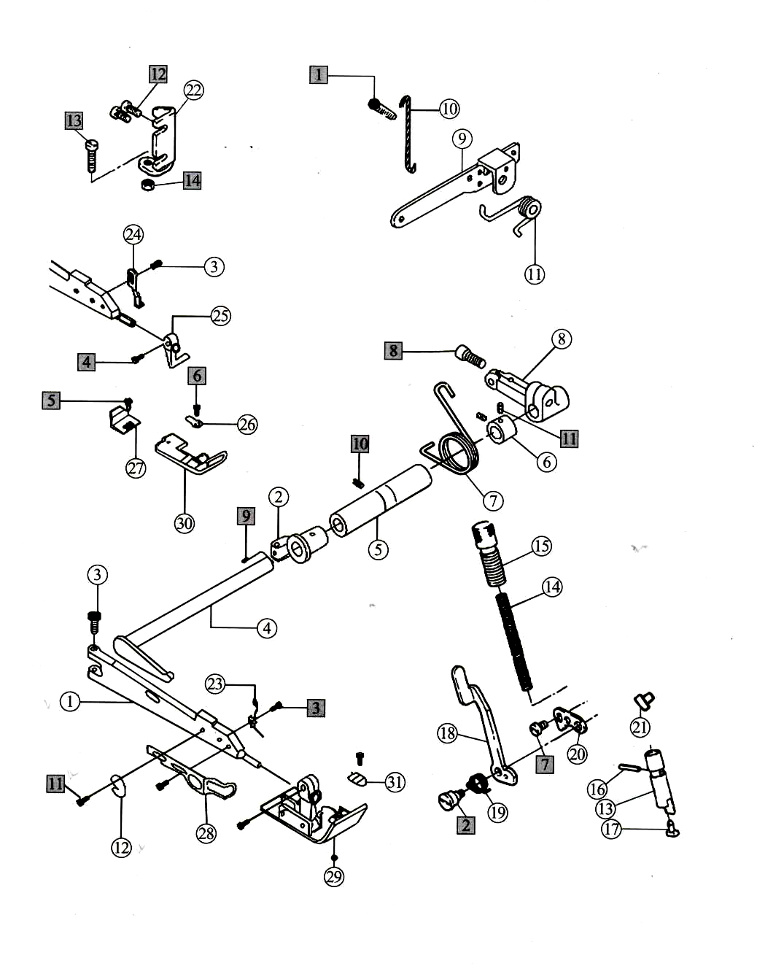

15. Lubrication Assemblies

NO | Part NO. | Description | Number
NO | Part NO. | Description | Three-thread | Four-thread | Five-thread
1 | KT04 | Oil pump worm gear | 1 | 1 | 1
2 | KT06E | Oil pump rotator bushing | 1 | 1 | 1
3 | KT07W | Oil pump rotator shaft | 1 | 1 | 1
4 | KT09E | Oil pump rotator | 1 | 1 | 1
5 | KT12W | Oil pump cover plate | 1 | 1 | 1
6 | KT64W | Oil screen holder | 1 | 1 | 1
7 | KT65W | Oil screen felt | 1 | 1 | 1
8 | 795-1508 | Oil pump asm | 1 | 1 | 1
9 | 795-1509 | Oil clearer cover | 1 | 1 | 1
10 | 795-1510 | Oil clearer cover seal ring | 1 | 1 | 1
11 | KT14-A | Oil clearer | 1 | 1 | 1
12 | 795-1512 | Oil tube joint I | 2 | 2 | 2
13 | 795-1513 | Oil tube joint II | 1 | 1 | 1
14 | KT26 | Oil tube shape ring | 4 | 4 | 4
15 | KT22 | Oil tube | 1 | 1 | 1
16 | 795-1516 | Washer | 4 | 4 | 4
17 | 795-1517 | Double node oil manager | 1 | 1 | 1
18 | 795-1518 | Oil tube joint | 1 | 1 | 1
19 | 795-1519 | oil manager screw | 1 | 1 | 1
20 | 795-1520 | Washer | 1 | 1 | 1
21 | 795-1521 | Oil tube | 1 | 1 | 1
22 | 795-1522 | Oil back tube | 1 | 1 | 1
23 | 795-1523 | Oil observer | 1 | 1 | 1
24 | KT51B | Oil pan | 1 | 1 | 1
25 | KT52B | Oil pan washer | 1 | 1 | 1
26 | KT56 | Oil seal | 1 | 1 | 1
27 | KT57 | Oil pan magnet | 1 | 1 | 1
28 | KT58 | Oil pan magnet cover | 1 | 1 | 1
1 | SK293 | Oil pump worn gear screw | 2 | 2 | 2
2 | SK245 | Oil cleaner screw | 3 | 3 | 3
3 | SK304 | Oil tube joint screw | 2 | 2 | 2
4 | 109-0804 | Oil screen cover screw | 4 | 4 | 4
5 | SK262 | Oil pan magnet cover screw | 1 | 1 | 1
6 | SK310 | Oil pan screw | 1 | 1 | 1
7 | SK278 | Oil pumps screw | 2 | 2 | 2
About Serial Number: О - denote part; □ - denote bolt, washer & nut.
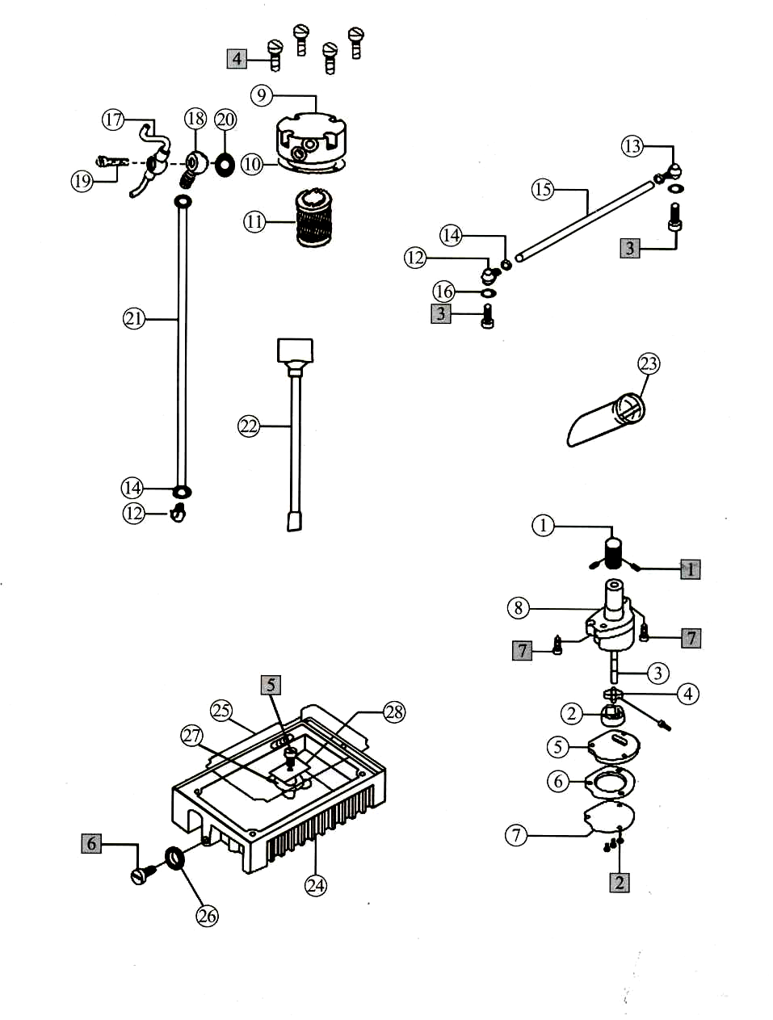

16. Feed Snap Assemblies

NO | Part NO. | Description | Number
NO | Part NO. | Description | Three-thread | Four-thread | Five-thread
1 | KU02 | Oil seal | 1 | 1 | 1
2 | KU14 | Needle cooler | 1 | 1 | 0
 | KU15 | Needle cooler | 0 | 0 | 1
3 | KU20 | Oil tube backer | 1 | 1 | 1
4 | KU22 | Oil wick | 1 | 1 | 1
5 | KU23-1B | Lower oil box cover | 1 | 1 | 1
6 | KU23-2B | Lower oil box | 1 | 1 | 1
7 | KU24 | Oil felt | 1 | 1 | 0
 | KU25 | Oil felt | 0 | 0 | 1
8 | KU26 | Oil wick | 1 | 1 | 1
9 | KU27D | Cloth guide holder | 1 | 1 | 1
10 | KU28D | Hinge plate | 1 | 1 | 1
11 | KU29 | Oil felt block | 1 | 1 | 1
12 | KU34 | Hinge pin | 1 | 1 | 1
13 | KU35 | Hinge spring | 1 | 1 | 1
14 | KU40 | Snap plate | 1 | 1 | 0
 | KU39 | Snap plate | 0 | 0 | 1
15 | KU43 | Snap plate bracket | 1 | 1 | 1
1 | SK233N | Snap late screw | 1 | 1 | 1
2 | WK07 | Washer | 1 | 1 | 1
3 | SK239 | Hinge spring screw | 1 | 1 | 1
4 | SK246N | Hinge screw | 2 | 2 | 2
5 | WK09 | Washer | 2 | 2 | 2
6 | NK26 | Nat | 1 | 1 | 1
7 | SK277N | Cloth guide holder screw | 1 | 1 | 1
8 | SK262 | Needle cooler screw | 3 | 3 | 3
About Serial Number: О - denote part; □ - denote bolt, washer & nut.
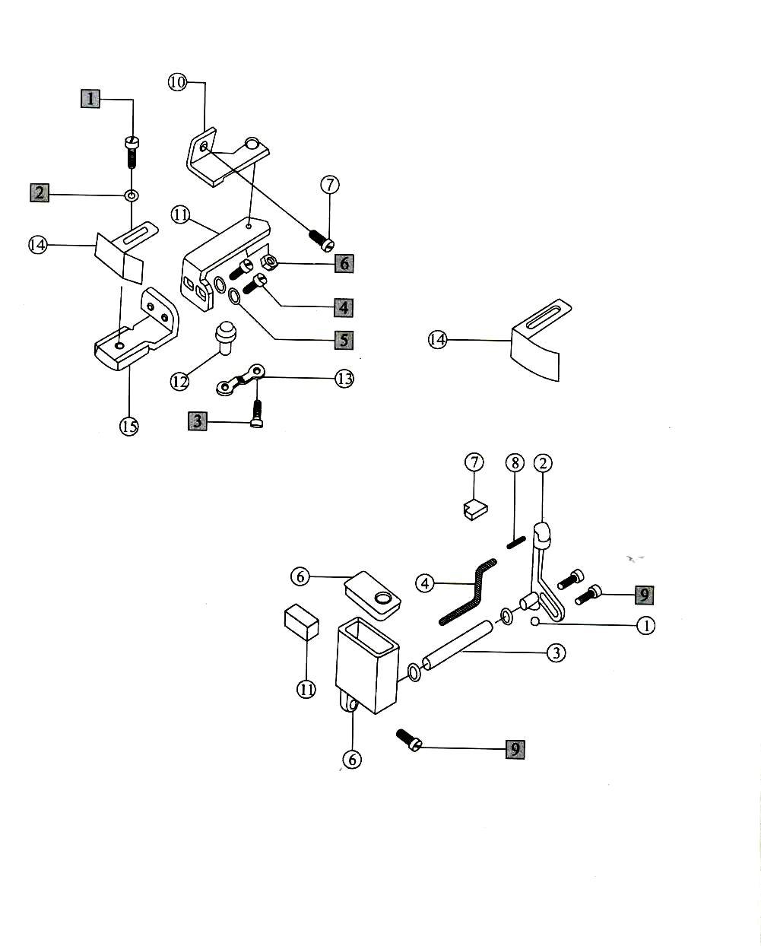

17. Thread Spool Assemblies

NO | Part NO. | Description | Number
NO | Part NO. | Description | Three-thread | Four-thread | Five-thread
1 | KW01E | Upper thread column | 1 | 1 | 1
2 | KW02E | Lower thread column | 1 | 1 | 1
3 | KW03E | Bushing | 1 | 1 | 1
4 | KW04E | Long thread spool troy bracket | 1 | 1 | 1
5 | KW05E | Thread guide hook | 4 | 4 | 4
6 | KW09B | Spool pin | 3 | 4 | 5
7 | KW12E | Spool tray | 3 | 4 | 5
8 | KW13E | Centering device | 3 | 4 | 5
9 | KW14E | Clamp plate | 1 | 1 | 1
10 | KW16 | Spool tray cushing | 3 | 4 | 5
11 | KW17B | Thread guide connecting bar | 1 | 1 | 1
12 | KW20E | Thread guide joint | 1 | 1 | 1
13 | KW22 | Thread stable holder | 1 | 1 | 1
14 | KW23 | Thread guide bar | 1 | 1 | 1
15 | KW26E | Thread spool tray bracket | 1 | 1 | 1
16 | KW28E | Thread guide plate | 1 | 1 | 1
17 | KW29E | Thread spool tray bracket | 1 | 1 | 1
18 | KW32E | Thread guide hook | 3 | 3 | 3
19 | KW36B | Rubber seal | 1 | 1 | 1
1 | SK421 | Thread guide hook screw | 4 | 4 | 4
2 | NK31B | Thread guide hook nut | 4 | 4 | 4
3 | SW01 | Thread guide washer | 4 | 4 | 4
4 | SK386B | Clamp plate screw | 3 | 3 | 3
5 | SK281B | Clamp holder screw | 1 | 1 | 1
6 | NK29B | Nut | 8 | 8 | 8
7 | WK25B | Lower washer | 2 | 2 | 2
8 | NK30 | Nut | 1 | 1 | 1
9 | SW04 | Washer | 4 | 4 | 4
10 | SK420 | Thread stand holder screw | 1 | 1 | 1
11 | SK422 | Thread stand holder join screw | 1 | 1 | 1
About Serial Number: О - denote part; □ - denote bolt, washer & nut.
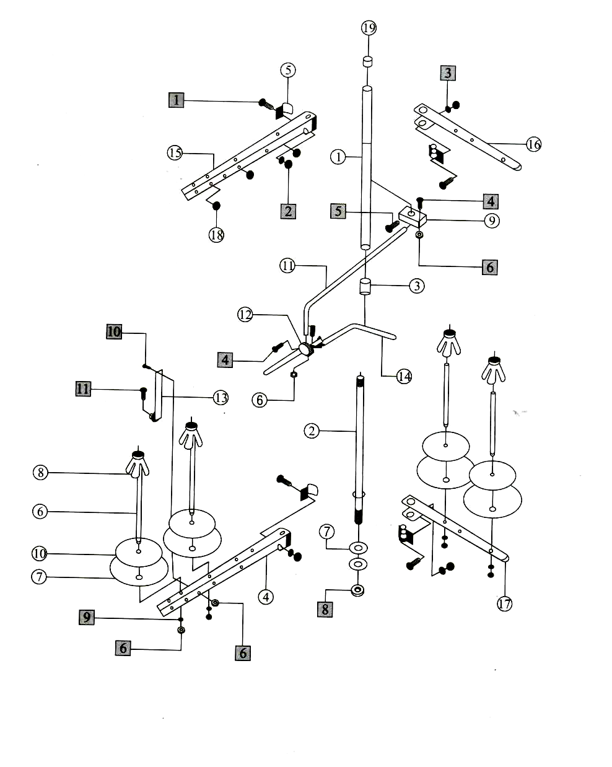

18. Plate Row Material Assemblies

NO | Part NO. | Description | Number
NO | Part NO. | Description | Three-thread | Four-thread | Five-thread
1 | KX01 | Machine head plate | 1 | 1 | 1
2 | KX02 | Head shockproof cushion | 3 | 3 | 3
3 | KX04 | Screw | 4 | 4 | 4
4 | KX05 | Screw | 4 | 4 | 4
5 | KX08 | Big washer | 12 | 12 | 12
6 | KX09 | Plate dog link bushing | 12 | 12 | 12
7 | KX10E | Row material trollgh bracket | 1 | 1 | 1
8 | KX12E | Row material trough I | 1 | 1 | 1
9 | KX13E | Row material trough II | 1 | 1 | 1
10 | SK391 | Row material seat screw | 3 | 3 | 3
11 | WK21 | Row material washer | 4 | 4 | 4
12 | SK392 | Row material screw | 4 | 4 | 4
About Serial Number: О -denote part; □ -denote bolt, washer & nut.
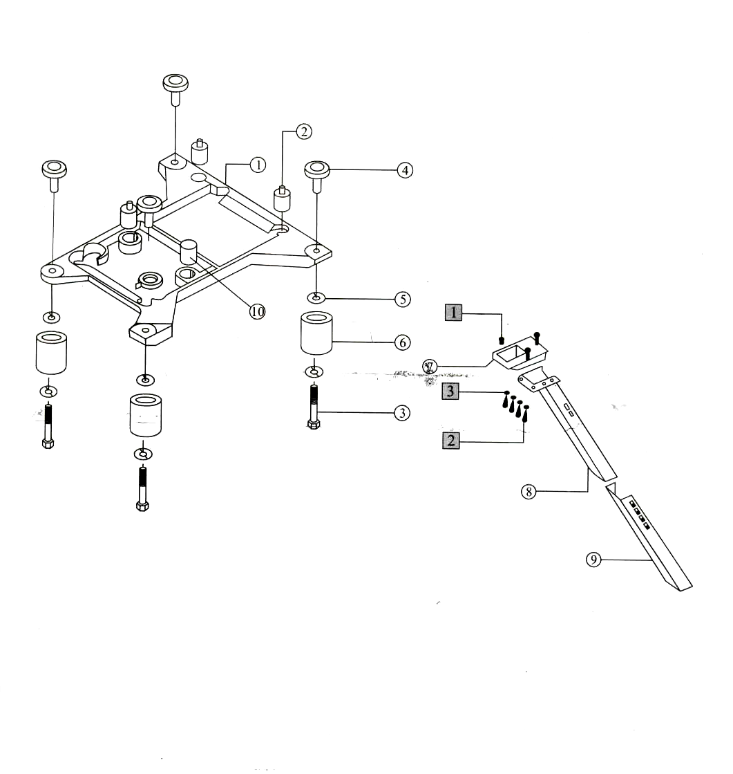

19. Accessories Assemblies

NO | Part NO. | Description | Number
NO | Part NO. | Description | Three-thread | Four-thread | Five-thread
1 | KY01 | Machine head cover | 1 | 1 | 1
2 | KY02 | Oil can/100cc | 1 | 1 | 1
3 | KY03 | Notes oil | 1 | 1 | 1
4 | KY04 | Tundish | 1 | 1 | 1
5 | KY05 | Oil can/50cc | 1 | 1 | 1
6 | KY07 | Spanner | 1 | 1 | 1
7 | KY08 | Spanner | 1 | 1 | 1
8 | KY09 | Spanner | 1 | 1 | 1
9 | KY10 | Inner-hexagon screw driver | 1 | 1 | 1
10 | KY11 | Inner-hexagon screw driver | 1 | 1 | 1
11 | KY12 | Inner-hexagon screw driver | 1 | 1 | 1
12 | KY13 | Inner-hexagon screw driver | 1 | 1 | 1
13 | KY14 | screw driver | 1 | 1 | 1
14 | KYI 5 | screw driver | 1 | 1 | 1
15 | KYI 6 | screw driver | 1 | 1 | 1
16 | KY18 | Tweezer | 1 | 1 | 1
17 | KY19 | Metal guide | 1 | 1 | 1
18 | KY20D | Presser foot base | 1 | 1 | 1
19 | KY21-A | Presser foot base chain | 1 | 1 | 1
20 | KY26 | Attachment box | 1 | 1 | 1
21 | SK216 | Thumble screw | 1 | 1 | 1
22 | DCX27 | Needle | 4 | 4 | 4
23 | KR35 | Lower knife | 1 | 1 | 1
24 | KT14-A | Oil filter | 1 | 1 | 1
About Serial Number: О -denote part; □ -denote bolt, washer & nut.
